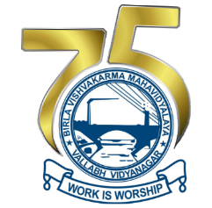
Copyright Form
3rd International Conference
On
“Women in Science & Technology: Creating Sustainable Career”
28 -30 December, 2023
Organized by
BVM Engineering College, Villabh Vidyanagar, Gujarat, India

Declaration:
In consideration of the fact that ICWSTCSC undertakes to publish my article:

- I affirm that the material in the above article has not been previously published and that I (and my coauthors) own and have not transferred elsewhere any rights of this article mentioned below.

- I affirm that I (and my coauthors) have obtained written permission to use any previously copyrighted material included in this article and that such documentation will be forwarded to ICWSTCSC for its files. I further affirm that I (and my coauthors) have stated any possible conflicts of interest within the article.

- I (and my coauthors) hereby assign and transfer all rights to publish abstract to ICWSTCSC proceedings, if any other organization or individual wish to republish then they need to seek permission either to ICWSTCSC Publications or the author/co-authors of the article and they must put the reference of this publication when they cite this article in any research literature survey including without limitation all rights of reproduction, derivation, distribution, sale, and display of the work, in whole or in part, including recompilation, in any and all forms of media now or hereafter known, including digital media, as protected by the laws of the India and foreign countries.

- In case my/our research paper get accepted by the review committee I/we will deposit/ transfer/pay the requisite registration fees to ICWSTCSC.

I sign for and accept the responsibility for transferring copyright of this article to ICWSTCSC.

Name (Corresponding author): Father’s Name: Institute Affiliation: Paper title:

Place:

Dated:
Signature (actual)

****

